**Lab 4b: Wireshark DHCP**

Họ và tên: Lê Đình Quân

MSSV: 1813698

1. Are DHCP messages sent over UDP or TCP?

Answer:

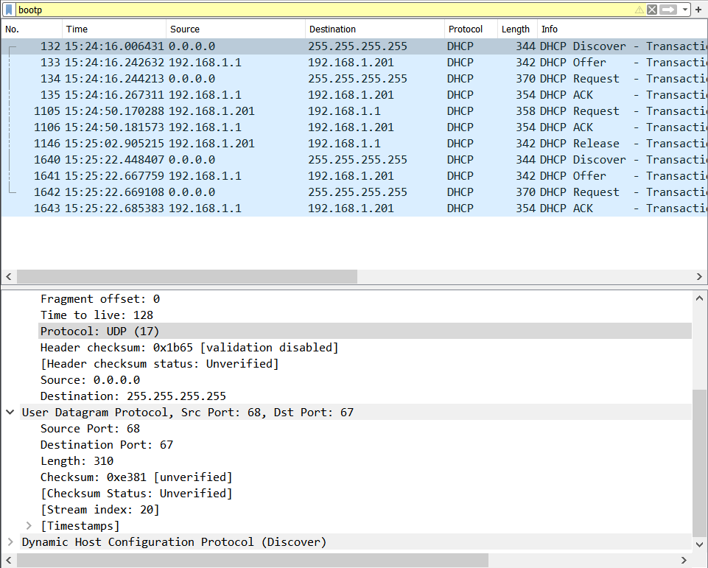

2. Draw a timing datagram illustrating the sequence of the first four-packet Discover/Offer/Request/ACK DHCP exchange between the client and server. For

each packet, indicated the source and destination port numbers. Are the port numbers the same as in the example given in this lab assignment?

Answer: port numbers giống nhau

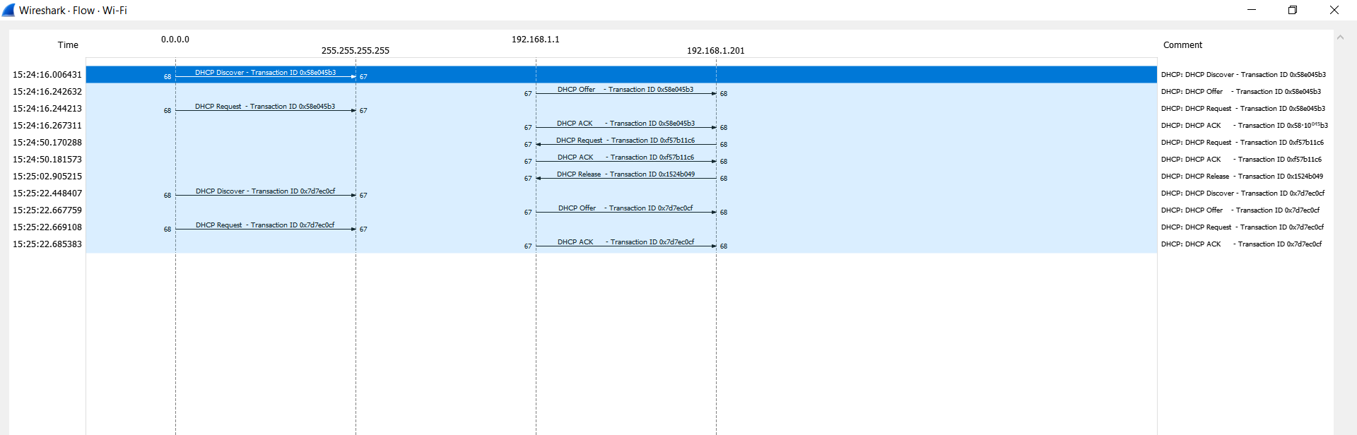

3. What is the link-layer (e.g., Ethernet) address of your host?

Answer: e8:6f:38:5d:72:b5

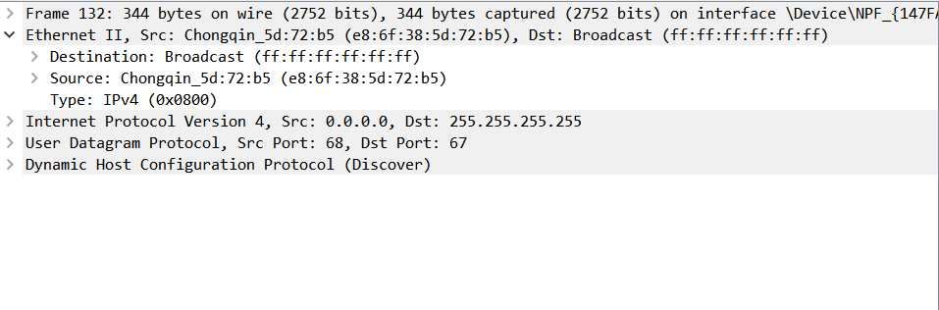

4. What values in the DHCP discover message differentiate this message from the

DHCP request message?

Answer: 53

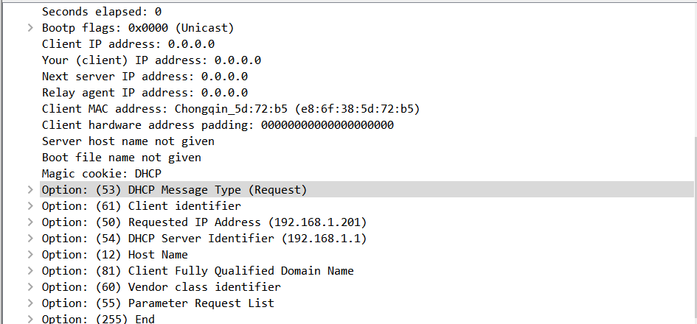

6. What is the value of the Transaction-ID in each of the first four (Discover/Offer/Request/ACK) DHCP messages?

Answer:

Discover: 0x58e045b3

Offer: 0x58e045b3

Request: 0x58e045b3

ACK: 0x58e045b3

What are the values of the Transaction-ID in the second set (Request/ACK) set of DHCP messages?

Answer:

Request: 0xf57b11c6

Ack: 0xf57b11c6

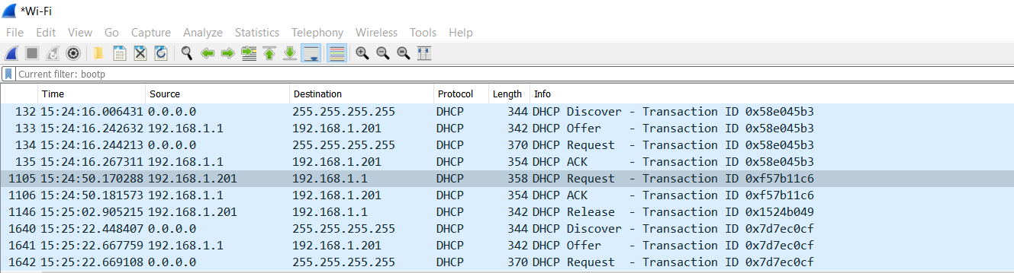

What is the purpose of the Transaction-ID field?

Answer: để DHCP server có thể phân biệt giữa client requests giữa request process.

6. A host uses DHCP to obtain an IP address, among other things. But a host’s IP

address is not confirmed until the end of the four-message exchange! If the IP

address is not set until the end of the four-message exchange, then what values are

used in the IP datagrams in the four-message exchange? For each of the four

DHCP messages (Discover/Offer/Request/ACK DHCP), indicate the source and

destination IP addresses that are carried in the encapsulating IP datagram.

Answer:

DCHP client và server sử dụng 255.255.255.255 làm destination address.

Client sử dụng source IP là 0.0.0.0

Server sử dụng IP của nó làm source

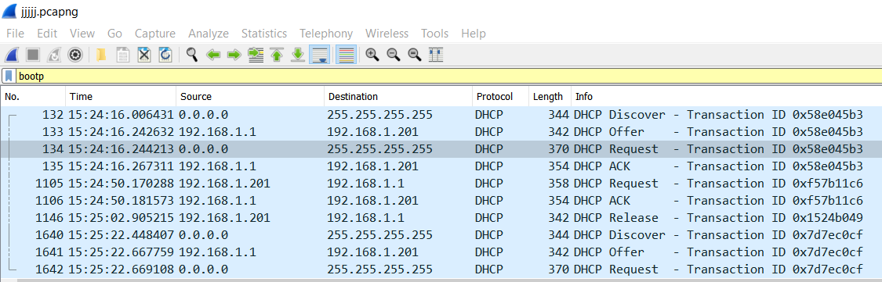

7. What is the IP address of your DHCP server?

Answer: 192.168.1.1

8. What IP address is the DHCP server offering to your host in the DHCP Offer message?

Answer: 192.168.1.201

Indicate which DHCP message contains the offered DHCP address.

Answer:

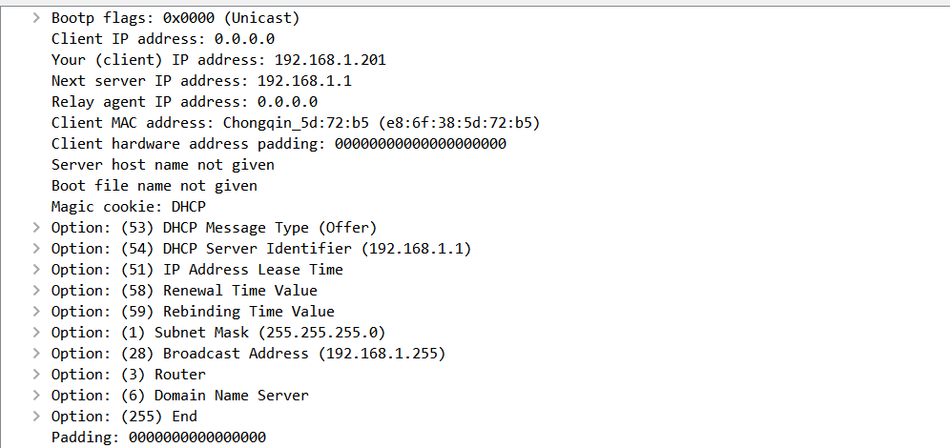

9. In the example screenshot in this assignment, there is no relay agent between the

host and the DHCP server. What values in the trace indicate the absence of a relay

agent? Is there a relay agent in your experiment? If so what is the IP address of

the agent?

Answer: Relay agent IP address: 0.0.0.0

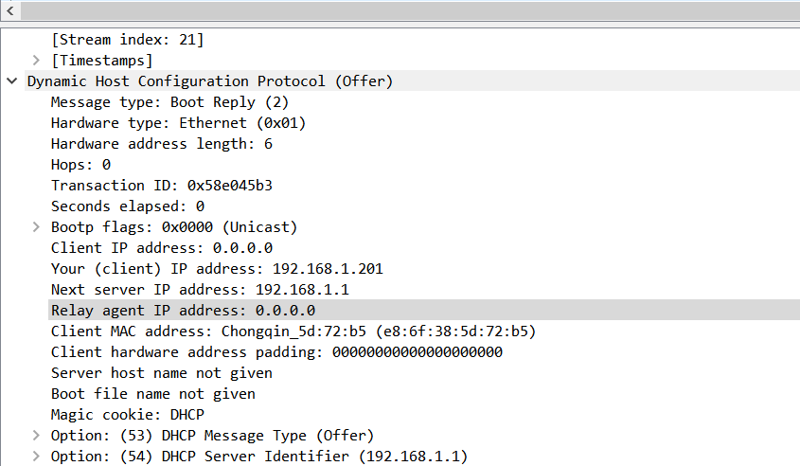

10. Explain the purpose of the router and subnet mask lines in the DHCP offer  
message

Answer:

Router line chỉ cho client biết cổng mặc định của nó.

Subnet mask line nói cho client biết subnet mask nó nên dung.

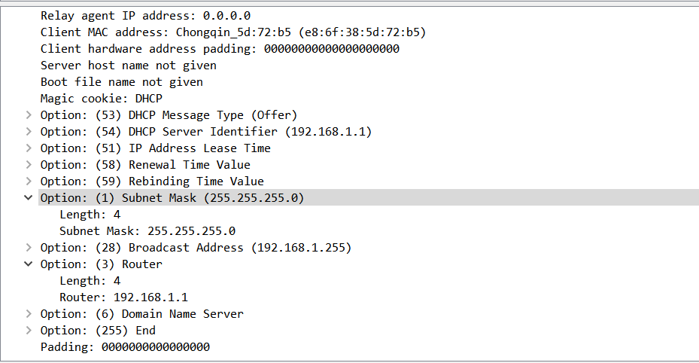

11. In the DHCP trace file noted in footnote 2, the DHCP server offers a specific IP

address to the client (see also question 8. above). In the client’s response to the first server OFFER message, does the client accept this IP address? Where in the client’s RESPONSE is the client’s requested address?

Answer:

Client chấp nhận IP trong offer message ở trong request message.

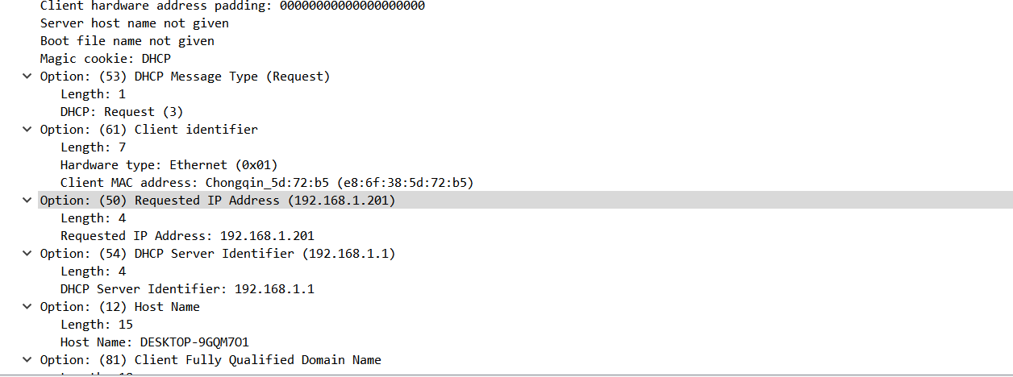

12. Explain the purpose of the lease time. How long is the lease time in your

experiment?

Answer: lease time nói cho client biết nó có thể dung IP đã được gán bởi server bao lâu trước khi nó phải gán một cái mới.

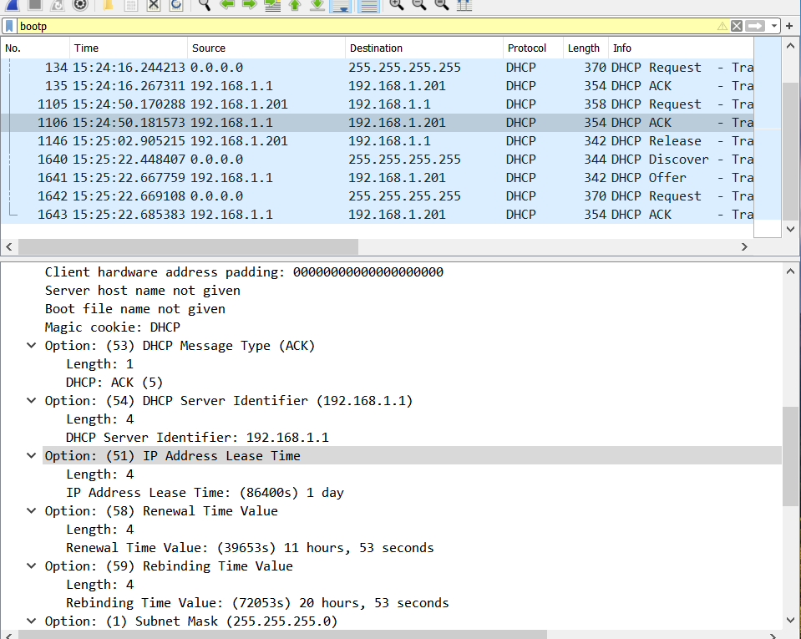

13. What is the purpose of the DHCP release message?

Answer: để giải phóng địa chỉ IP lại cho server

Does the DHCP server issue an acknowledgment of receipt of the client’s DHCP request?

Answer: không có minh chứng

What would happen if the client’s DHCP release message is lost?

Answer: client giải phóng địa chỉ IP, nhưng server sẽ không gán lại địa chỉ đó

14. Clear the bootp filter from your Wireshark window. Were any ARP packets sent

or received during the DHCP packet-exchange period? If so, explain the purpose

of those ARP packets.

Answer: chúng dường như là các broadcasts gửi bởi mạng để xây dựng các địa chỉ IP đã biết bởi mạng khách hang.

